Nevada Division of Public and Behavioral Health
Early Hearing Detection and Intervention (EHDI) Program
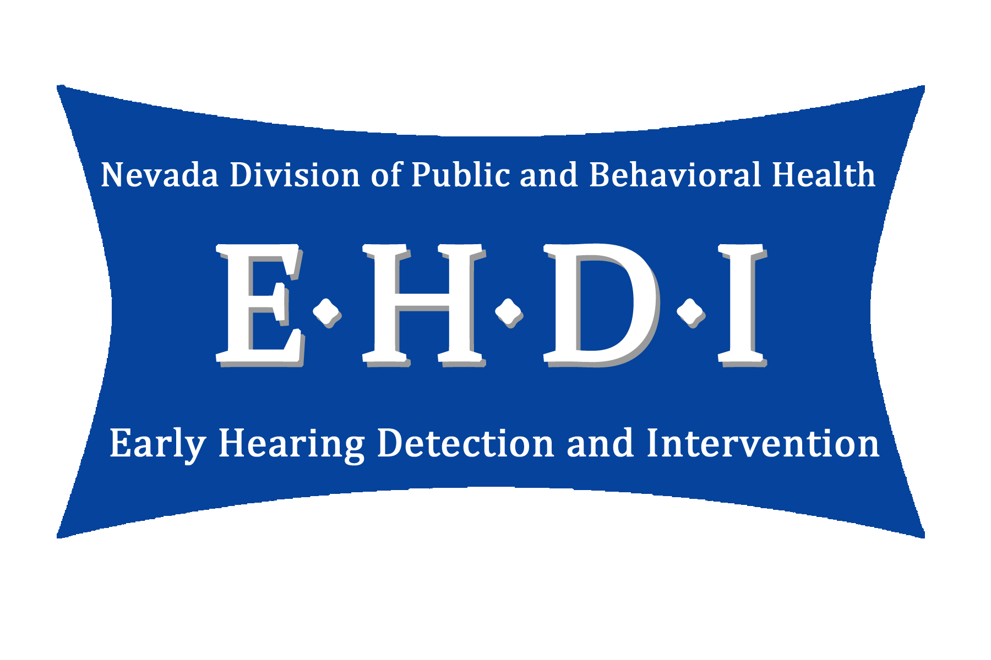
GUIDELINES FOR INFANT AUDIOLOGIC ASSESSMENT

STATE OF NEVADA

CODY L. PHINNEY, MPH.
Administrator

TRACY D. GREEN, MD
Chief Medical Officer

BRIAN SANDOVAL
Governor

RICHARD WHITLEY, MS.
Director

DEPARTMENT OF HEALTH AND HUMAN SERVICES

DIVISION OF PUBLIC AND BEHAVIORAL HEALTH

Bureau of Child, Family & Community Wellness
4150 Technology Way
Carson City, Nevada 89706

Early Hearing Detection and Intervention
4150 Technology Way, Suite 210
Carson City, Nevada 89706
Telephone (775) 684-4285 · Fax (775) 684-5998

ACKNOWLEDGEMENTS

These guidelines were developed in 2012 by a workgroup comprised mainly of Nevada audiologists experienced in the assessment and management of hearing loss in young children. They are based on current national guidelines from the American Speech-Language-Hearing Association, the American Academy of Audiology, the Joint Committee on Infant Hearing, and the National Center for Hearing Assessment and Management. The Nevada Early Hearing Detection and Intervention (EHDI) Program wishes to thank the workgroup members for their commitment to the belief that high quality audiological services positively impacts the lives of infants and their parents.

Workgroup Members:

Mary Carpi, Au.D., CCC-A
Audiologist, Clark County School District
Jennifer Cornejo, M.A., CCC-A, F-AAA
Audiologist, University of Nevada School of Medicine, Dept. of Surgery - ENT
Andrea Esp, MPH, CPH, CHES
Coordinator, Nevada Early Hearing Detection and Intervention Program
Timothy Hunsaker, Au.D.
Audiologist, Desert Valley Audiology
Susan Lloyd, Au.D., CCC-A, F-AAA
Audiologist
Sue McKinley, M.A., CCC-A/SLP, F-AAA
Educational Audiologist, Washoe County School District
Diane Miller, Au.D., CCC-A
Audiologist, Nevada Early Intervention Services - Northwest
Follow-up Coordinator, Nevada Early Hearing Detection and Intervention Program
Angelia Peacock, Au.D., CCC-A, F-AAA
Audiologist, Nevada Early Intervention Services - South
Little Ears Audiology
Christine Schellin, Au.D., F-AAA
ABA Board Certified Audiologist, Silver State Hearing and Balance
Abbie Stevenson, Au.D., F-AAA
Audiologist, Nevada Early Intervention Services - Northwest
Nevada Early Hearing Detection and Intervention Program
Megan Swank, Au.D., CCC-A, F-AAA
Audiologist, Silver State Hearing and Balance

NEVADA EARLY HEARING DETECTION AND INTERVENTION PROGRAM

INFANT AUDIOLOGIC ASSESSMENT GUIDELINES

Table of Contents

Section Heading Page

An Overview of the Nevada Early Hearing Detection and Intervention Program 5
Introduction to the Nevada Infant Audiologic Assessment Guidelines 6

The Comprehensive Infant Audiologic Assessment 7

Parent Counseling, Recommendations and Referrals 10

Principles of Audiological Management 11
Reporting Test Results to the Medical Care Provider, the State Health Division, 12
and Part C – Early Intervention

Bibliography 13

Appendix
A. Risk Factors for Delayed Onset and Progressive Hearing Loss 14
B. Nevada EHDI Audiological Follow-up Reporting Form 16
C. Nevada Early Intervention Program Referral Forms 18
Nevada Early Intervention Services Northwest
Nevada Early Intervention Services Northeast Nevada Early Intervention Services South

AN OVERVIEW OF THE NEVADA EARLY HEARING DETECTION AND INTERVENTION PROGRAM

Hearing loss is the most frequent congenital condition occurring in 2-3 of every 1000 births. Nationally, the average age of identification of hearing loss has been reduced from 2.5 years to approximately 6 months of age since the implementation of universal newborn hearing screening. Recent studies have shown that infants who are identified with hearing loss before 6 months of age, and receive appropriate intervention, demonstrate significantly better receptive and expressive language skills than children whose hearing losses are identified later.

Early hearing detection and intervention (EHDI) was initiated in Nevada on January 1, 2002 following legislative enactment of Nevada Revised Statutes 442.500 – 590. This law mandates that hospitals with more than 500 births per year provide hearing screening on all newborns prior to discharge. The legislation also stipulates that newborns not passing the screening are referred for an in-depth diagnostic hearing evaluation. The EHDI Program was developed within the Division of Public and Behavioral Health to ensure infants and toddlers with hearing loss are identified as early as possible and provided with timely and appropriate follow-up services. This is in accordance with the National EHDI 1-3-6 Plan which states:
- All infants should be screened for hearing loss prior to hospital discharge or before 1 month of age.
- All infants not passing the hearing screening (in one or both ears) should receive a complete diagnostic audiologic evaluation before 3 months of age.
- All infants indentified with hearing loss should be enrolled in appropriate early intervention services before 6 months of age.
- All infants identified with hearing loss should be linked to a medical home.*
- All infants identified with hearing loss should be provided with information regarding parent support organizations.

The Joint Committee on Infant Hearing, the Centers for Disease Control and Prevention, and the “Healthy People 2020” document of the U.S. Department of Health and Human Services recommend these goals to prevent or minimize developmental delays caused by hearing loss. The Joint Committee member organizations that have adopted these goals include: the Alexander Graham Bell Association for the Deaf and Hard of Hearing, the American Academy of Audiology, the American Academy of Otolaryngology-Head and Neck Surgery, the American Academy of Pediatrics, the American Speech-Language-Hearing Association, the Council on Education of the Deaf, and the Directors of Speech and Hearing Programs in State Health and Welfare Agencies.

The Nevada EHDI Program supports a statewide comprehensive and coordinated interdisciplinary program of newborn hearing screening and follow-up care for those who do not pass the screening. Through tracking and monitoring activities, the program ensures infants are screened and receive timely and appropriate follow-up hearing testing and early intervention services as indicated in accordance with Nevada Revised Statutes. Ongoing audiologic consultation and trainings are available to hospital and screening staff, as well as to physicians, audiologists, community agencies and families. The program promotes and participates in public awareness activities regarding the EHDI Program, infant hearing loss, and communication development.

*The medical home is an approach to providing health care services in which care is accessible, family centered, continuous, comprehensive, coordinated, compassionate and culturally effective.

INTRODUCTION TO THE NEVADA INFANT AUDIOLOGIC ASSESSMENT GUIDELINES

The purpose of this document is to provide a description of recommended procedures for audiologists performing follow-up audiological assessment of infants identified during universal newborn hearing screening. Infants are candidates for audiologic assessment when they have not passed an initial hearing screening in one or both ears prior to discharge from the birthing facility and an out-patient rescreen within 4 weeks of discharge.

There are certain situations in which it may be appropriate for an audiologist to perform a hearing screening rather than a complete assessment. An audiologist may perform the initial hearing screening for an infant who was not screened at the birthing facility and for infants born at home or at a non-screening facility. It is also appropriate for an audiologist to perform the out-patient rescreen if such a rescreen has not already occurred. In this situation, the audiologist should rescreen the infant’s hearing using the same type of physiologic measure utilized during the initial screening. An infant who was initially screened using automated auditory brainstem response (AABR) should not be rescreened using otoacoustic emissions (OAE) equipment. Infants who resided in the neonatal intensive care unit (NICU) should only be screened/rescreened using ABR technology due to the risk of neural hearing loss. Rescreening should always include both ears, even if only one ear did not pass the initial hearing screen.

Newborns failing the screening/rescreening procedures in either one or both ears require an audiological evaluation by an audiologist experienced in assessing infants. The audiologist should have the equipment necessary to complete all appropriate evaluation procedures. The goal of the audiologic assessment is to determine the presence or absence of hearing loss. When hearing loss is confirmed, a description of the type, degree, and configuration is necessary to plan appropriate intervention strategies.

Screening and diagnostic test results should be provided to the Nevada EHDI Program after each evaluation until it is determined that the infant has normal hearing or until the type, degree, and configuration of permanent hearing loss have been diagnosed.

Comprehensive evaluations should be completed by audiologists experienced in pediatric hearing assessment. Audiologists, by virtue of academic degree, clinical training, and license to practice, are uniquely qualified to provide services related to the prevention of hearing loss and the audiological diagnosis, identification, assessment as well as the nonmedical and nonsurgical treatment of hearing loss in infants and children. Professional responsibility requires audiologists to test, diagnose, and provide remediation only in those areas in which their knowledge level is commensurate with national standards of care. It is each audiologist’s responsibility to recognize their unique skill sets and abilities. If the practitioner does not have the expertise and equipment to follow these guidelines, the infant should be referred to a professional equipped for and qualified in infant audiologic assessment.

These guidelines are not a description of how to carry out an audiologic assessment. They were developed to identify the essential components of an audiologic assessment in order to facilitate the confirmation of hearing loss by three months of age. Each child presents unique characteristics that may influence the assessment process. Although some of the recommended assessment principles and protocol pertain specifically to newborn hearing screening follow-up, the guidelines are appropriate for all children age birth through three years who are suspected of having hearing loss.

THE COMPREHENSIVE INFANT AUDIOLOGIC ASSESSMENT

All infants who have not passed their newborn hearing screen and a subsequent out-patient rescreen in one or both ears requires a comprehensive audiological evaluation by an audiologist experienced in assessing infants. Comprehensive assessments are also warranted for infants and toddlers who passed their newborn hearing screen but are identified with risk factors for delayed onset hearing loss or speech and language delays, or when there are parental or professional concerns. In order to expedite the diagnosis, the audiologist should have both the equipment and expertise necessary to complete all evaluation procedures described below. If the practitioner is unable to follow these guidelines, the infant should be referred to a professional equipped for and qualified in infant assessment.

Although some of the underlying principles listed below pertain specifically to follow-up of newborn hearing screening, others provide guidance to the audiologic assessment of any young child suspected of having hearing loss. As with all guidelines, professional judgment must be used to meet the individual needs of each child.

UNDERLYING PRINCIPLES

- It may be appropriate to provide a hearing rescreen prior to an audiologic assessment if the infant did not pass his/her initial screening prior to discharge, and an out-patient rescreen has not yet occurred. The audiologist should rescreen the infant’s hearing using the same type of physiologic measure utilized during the initial screening. For example, an infant who was initially screened using AABR should not be rescreened using OAE equipment. Infants who resided in the NICU should only be rescreened using ABR technology due to the risk of neural hearing loss. Rescreening should always include both ears, even if only one ear did not pass the initial hearing screen.
- The focus of the diagnostic testing of infants is physiologic assessment. Behavioral audiometry may be appropriate for infants with developmental levels of six months and over if reliable ear-specific and frequency-specific information can be obtained.
- The goal of the diagnostic assessment is to determine the presence or absence of hearing loss, as well as to assess auditory thresholds, status of auditory nerve and brainstem pathways, and to determine locus of hearing impairment if abnormal results are found. A description of the type, severity, and configuration of hearing loss is necessary to plan appropriate referrals, management, and intervention strategies.
- Infants who did not pass an (A)ABR hearing screen or rescreen or had NICU stays of greater than five days, should receive ABR testing as part of the comprehensive audiologic assessment.
- Click ABR alone is not sufficient to determine hearing thresholds. Tone burst ABR or auditory steady state response (ASSR) techniques are required to define the degree of hearing loss present across the frequency range used for speech. Because a click ABR stimulates the cochlea primarily in the 2000 – 4000 Hz region, an infant may pass a click ABR by having normal activity in any portion of that region. High frequency, upward sloping, and other odd configurations of hearing loss can be misdiagnosed using click ABR alone.
- ABR testing for infants under the age of six months should be conducted during natural sleep when possible. Sedation may be necessary when testing older infants and toddlers.
- Completion of the diagnostic test battery shall not be delayed beyond three months of age to allow for resolution of middle ear effusion. Bone conduction ABR procedures should be used as a means to confirm hearing status if a continuing middle ear condition is present.
- A comprehensive assessment should include both ears even if only one ear did not pass the screening or rescreening.
- Insert earphones are the transducer of choice, unless contraindicated.
- Completion of the audiologic assessment at one site and in one visit is preferable.
- If an audiologist does not have the expertise and equipment to follow these guidelines, the infant and family should be referred to an audiologist who has this capability.
- Assessment results should be reported to State of Nevada, Early Hearing Detection and Intervention (EHDI) Program after each evaluation until it is determined that the infant has normal hearing or until the type, degree, and configuration of permanent hearing loss has been diagnosed.

RECOMMENDED ASSESSMENT PROTOCOL

- Recommended Test Battery for Infants Birth to 6 Months of Age
  - Child and family history
  - Evaluation of risk factors
  - Parent report of infant’s responses
  - Otoscopy
  - Tympanometry using 1000 Hz probe tone (poor reliability for probe tones below 600 Hz)
  - Otoacoustic emissions (OAE) to establish cochlear outer hair cell function
  - Click ABR for measurement of neural integrity at high levels of 70-90 dBnHL to identify Waves I, III, V and compare to age related latency normative data (Compare condensation vs. rarefaction stimulus if indicators for neural hearing loss/AN are present.)
  - Tone burst ABR or steady state ABR (ASSR) for frequency specific threshold estimation (at minimum, testing should include a low frequency such as 500 Hz and a high frequency such as 2000 or 4000 Hz for each ear, attempt down to 20 dBnHL or until response extinguishes)
  - Bone conduction ABR when air conduction thresholds are elevated
  - Clinical observation to corroborate parental report of infant’s responses

Note: Insert earphones are recommended unless contraindicated.
If infant previously failed an ABR screening, the evaluation must include ABR testing.

- Recommended Test Battery for Infants and Toddlers 6 - 36 Months of Age
Include the following for subsequent testing of older infants and toddlers, or initial assessment of those with new concerns or who did not have timely or appropriate follow-up:
  - Child and family history
  - Parent report of auditory, visual and communication milestones
  - Otoscopy
  - Acoustic immittance measures (tympanometry and reflexes)
  - Otoacoustic emissions (OAE) to establish cochlear outer hair cell function
  - Speech awareness and/or speech reception thresholds for each ear
  - Behavioral audiometry (visual reinforcement or conditioned play) across frequencies for each ear (250 – 4000 Hz recommended)
  - If frequency specific thresholds cannot be obtained for each ear through behavioral audiometry techniques or if ABR testing has not been performed in the past, the following ABR tests are warranted:
    - Click ABR for measurement of neural integrity at high levels of 70-90 dBnHL to identify Waves I, III, V and compare to age related latency normative data (Compare condensation vs. rarefaction stimulus if indicators for neural hearing loss/AN are present.)
    - Tone burst ABR or steady state ABR (ASSR) for frequency specific threshold estimation (at minimum, testing should include a low frequency such as 500 Hz and a high frequency such as 2000 or 4000 Hz for each ear, attempt down to 20 dBnHL or until response extinguishes)

Note: Insert earphones are recommended unless contraindicated.

PARENT COUNSELING, RECOMMENDATIONS AND REFERRALS

FOR INFANTS WITH NORMAL HEARING
- Review with parents:
  - Results of the audiologic assessment
  - Information about typical speech, language and listening development
  - Risk factors for delayed onset or progressive hearing loss (Appendix A)
  - Recommended timeframes for re-assessment if risk factors are present; retest at least once by 24-30 months, or more frequently for some conditions
- Refer every child with middle ear dysfunction for a medical evaluation and/or a follow-up hearing assessment.

FOR INFANTS WITH CONFIRMED HEARING LOSS
- Review with parents:
  - Results and implications of the audiologic assessment
  - Unbiased information/resources regarding amplification (hearing aids, cochlear implants, FM systems) , education and communication options
  - Information regarding the need for a primary care provider and/or medical home
  - Information regarding the importance of, and resources for, early intervention
  - The availability and importance of parent to parent support
- Refer every child with middle ear dysfunction for a medical evaluation and/or a follow-up hearing assessment. Completion of the diagnostic test battery should not be delayed beyond 3 months of age pending resolution of middle ear effusion.
- Refer every child with hearing loss to an otolaryngologist for examination and clearance for amplification.
- Refer every child with hearing loss to an early intervention program.
- In consultation with the infant’s primary care physician, specialty evaluations such as genetic testing and ophthalmology should be offered.
- If appropriate, initiate the amplification process and ensure fitting by an audiologist experienced in working with infants and toddlers.

PRINCIPLES OF AUDIOLOGICAL MANAGEMENT

- Infants with confirmed hearing loss should be monitored audiologically at least every six months through age 3 and annually thereafter or until hearing is stable.
- Most infants and toddlers with hearing loss benefit from some form of personal amplification.
- If chosen by family, selection and fitting of amplification should occur within one month of confirmation of hearing loss. Loaner hearing aids from state, non-profit, or manufacturer sponsored programs should be utilized to ensure timely access to amplification when financial or insurance barriers are present.
- Definitive resolution of otitis media/middle ear fluid should never delay the fitting of an amplification device.
- Based on degree of residual hearing, those with minimal, mild and unilateral hearing loss should be considered for trial use of amplification and/or personal FM systems.
- Trial use of amplification may be appropriate for children with neural hearing loss such as auditory neuropathy/auditory dyssynchrony (AN/AD) when supported by reduced behavioral audiometric thresholds.
- Hearing aid fitting and programming should be based on frequency specific thresholds for each ear. For infants under 6 months of age, frequency specific ABR is necessary for accurate estimation of the degree and configuration of hearing loss. Click ABR alone is not sufficient for accurate hearing aid fitting.
- Hearing aid fitting should be provided by an audiologist knowledgeable in the current pediatric amplification protocol developed by the American Academy of Audiology and experienced in fitting the very young child.
- Verification and validation measures should be utilized.
- Hearing Instrument orientation and training should be discussed, demonstrated and sent home in a written or video format. When possible, include all family members, caregivers, early interventionists, and the child.
- Fitting of amplification on an infant or young child is an ongoing process. Minimally, follow-up appointments should occur every three months during the first two years of amplification, and at least every six months after that.
- Cochlear implantation should be given careful consideration for children who meet the audiological requirements and receive limited benefit from trial use of appropriately fit hearing aids.

REPORTING TEST RESULTS TO THE MEDICAL CARE PROVIDER, THE STATE DIVISION OF PUBLIC AND BEHAVIORAL HEALTH, AND PART C - EARLY INTERVENTION

- For Infants with Normal Hearing
  - Report assessment results to the primary medical care provider.
  - Provide assessment results to the Nevada State, Early Hearing Detection and Intervention (EHDI) Program. Fax or email the “Audiological Follow-Up Report for Newborn Hearing Screening Referrals” form along with a copy of the actual audiology report/result. (Appendix B)

- For Infants with Hearing Loss
  - Report assessment results to the primary medical care provider.
  - Provide assessment results to the Nevada State, Early Hearing Detection and Intervention (EHDI) Program after each evaluation until it is determined that the infant has normal hearing or the type, degree, and configuration of permanent hearing loss has been diagnosed. Fax or email the “Audiological Follow-Up Report for Newborn Hearing Screening Referrals” form along with a copy of the actual audiology report/results. (Appendix B)
  - Provide notification of hearing aid fitting or cochlear implantation to the Nevada State, Early Hearing Detection and Intervention (EHDI) Program by faxing or emailing the “Audiological Follow-Up Report for Newborn Hearing Screening Referrals” form. (Appendix B)
  - Provide the assessment results and the family’s contact information to the Part C – Early Intervention Program. The Individuals with Disabilities Education Act, Sec. 303.321, requires that referrals be made within seven working days after a child has been identified. (Appendix C)

Bibliography

Ad Hoc Task Force. (1992). The Medical Home. Pediatrics, 90, 774. – Medical home

American Academy of Audiology. (2003). Pediatric Amplification Protocol.

American Academy of Pediatrics. (2002). Universal Newborn Hearing Screening.

American Speech-Language-Hearing Association. (2008). Guidelines for Audiologic
Assessment of Children from Birth to 5 Years of Age.

American Speech-Language-Hearing Association. (2008). Guidelines for Audiologists Providing
Information and Adjustment Counseling to Families of Infants and Young Children With
Hearing Loss Birth to 5 Years of Age.

Joint Committee on Infant Hearing. (2007). Year 2007 Position Statement: Principles and
Guidelines for Early Hearing Detection and Intervention Programs. Pediatrics, 120, 898-921.

Screening of Hearing of Newborn Children & NRS 444.500-590. (2002).

Screening of Hearing of Newborn Children & NAC 442.850-860. (2002).

Yoshinaga-Itano, C., Sedey, A., Couldter, D. K., Mehl, A.L. (1998). Language of Early- and
later-identified Children with Hearing Loss. Pediatrics, 102, 1161-1171.

Appendix A

Risk Factors Associated with Permanent Congenital, Delayed-Onset, or Progressive Hearing Loss in Childhood

Risk Factors Associated with Permanent Congenital, Delayed-Onset, or Progressive Hearing Loss in Childhood

- Caregiver concern regarding hearing, speech or language development

- Family history of permanent childhood hearing loss

- Neonatal intensive care unit admission greater than five days

- Mechanical ventilation or extracorporeal membrane oxygenation (ECMO)

- In utero infections
  - such as cytomegalovirus (CMV), herpes, rubella, syphilis and toxoplasmosis

- Hyperbilirubinemia requiring exchange transfusion

- Exposure to ototoxic medications
  - such as gentamycin, tobramycin, furosemide/Lasix

- Craniofacial anomalies, especially of the ear or temporal bone
  - such as ear tags, ear pits, microtia, atresia

- Physical findings, such as a white forelock, that are associated with a syndrome known to include permanent hearing loss

- Syndromes associated with permanent, delayed-onset, or progressive hearing loss
  - such as neurofibromatosis, osteopetrosis, Usher, Waardenburg, Alport, Pendred

- Neurodegenerative disorders and sensory motor neuropathies
  - such as Hunters, Friedreich ataxia and Charcot-Marie-Tooth

- Postnatal infections associated with sensorineural hearing loss
  - such as bacterial or viral meningitis, especially herpes virus and varicella

- Head trauma
  - such as basal skull and temporal bone fractures requiring hospitalization

- Chemotherapy

Appendix B

Nevada EHDI Audiological Follow-up Reporting Form

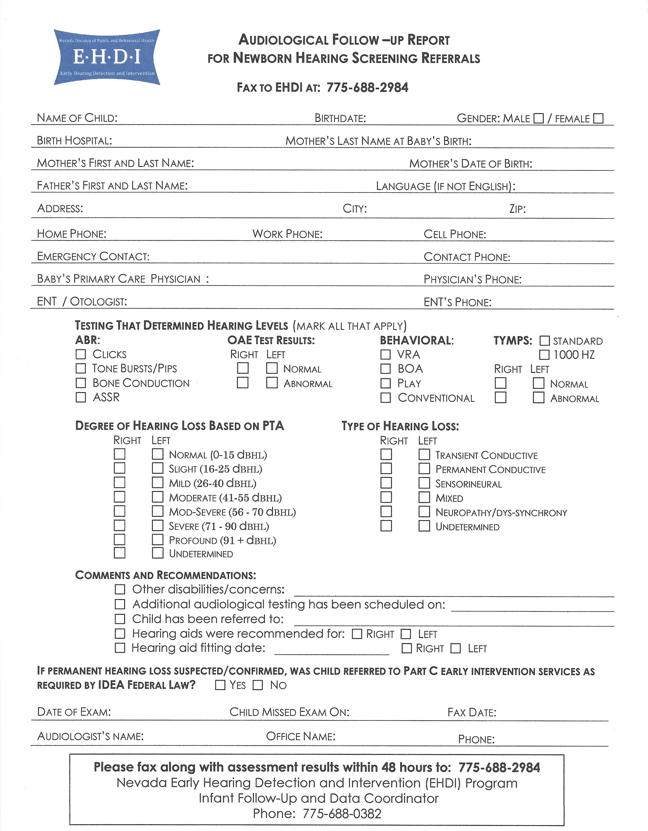

Appendix C

Nevada Early Intervention Program Referral Forms

Nevada Early Intervention Services Northwest
Nevada Early Intervention Services Northeast
Nevada Early Intervention Services South

Please complete this form for referring a child to Early Intervention (Part C) if you prefer to do so in writing. Also please indicate the feedback that you want to receive from the Early Intervention Program in response to your referral. Diagnosis of a specific condition or disorder is not necessary for a referral however, children must show a 50% delay in 1 area or a 25% delay in 2 areas of development to qualify for early intervention services.

Nevada Early Intervention Program Referral Form

Parent/Child Contact Information
Child Name: _________________________________________________________________________ Interpreter Need: Yes No
Date of Birth: ______/_______/_______ Child Age: (Months) _______ Gender: M F Race: ____________________
Home Address: ____________________________________________________________________________________________________
Parent/Guardian_________________________________________ Relationship to Child: ________________________________________
Primary Language: ___________________ Home Phone: _______________ ______ Other Phone:_________________________________
Second Contact: ________________________________ Relationship to Child: _______________ Phone Number: ____________________
Emergency Contact: ___________________ Relationship to Family: _______________ Phone or Cell Number: _______________________

Reason(s) for Referral to Early Intervention
(Please check all that apply)
- Identified condition or diagnosis (e.g., spina bifida, PKU, etc.): ___________________________________________________________
- Suspected developmental delay or concern (Please circle areas of concern):
Motor/Physical Cognitive Social/Emotional Speech/Language Behavior Vision Hearing
Newborn Hearing Screen Referral: Passed Failed __________________________________________________________________
Other (Describe): __________________________________________________________________________________________________

Referral Source Contact Information
Referring Agency: _________________________________________________________________________________________________
Contact Name: ______________________________________________________________ Date of Referral: _______/________/_______
Address: _________________________________________________________________________________________________________
Office Phone_______________________ Office Fax: ________________________ E-mail_______________________________________

Feedback Requested by the Referral Agency (For Professional Use Only)
Date Referral Received: ______/_______/_______ Date of Initial Appointment with Child/Family: ______/_______/_______
Name of Assigned Service Coordinator: ________________________________________________________________________________
Office Phone: _____________________ Office Fax: ____________________________ E-mail: ___________________________________
After initial appointment, please send the following information:
- Status of Initial Family Contact □ Family Declined Service
- Developmental Evaluation Results □ Eligibility Status □ Eligible □Not Eligible
- Other (Describe): _____________________________________

Release of Information Consent (Optional)
I,___________________________________________(Print name of parent or guardian), give my permission for my pediatric health care provider and/or Early Intervention Services, _____________________________________________(print provider’s name), to share any and all pertinent information regarding my child,_________________________________________________(print child’s name).
Parent/Legal Guardian Signature________________________________________________________ Date:________/________/________

Send Referral To:
Nevada Early Intervention Services Northwest
FAX 775-688-2984
This form was adapted by Nevada from a form created through collaboration between the American Academy of Pediatrics and the Tracking, Referral and Assessment Center for Excellence, Orelena Hawks Puckett Institute, Inc. The development of this form was supported, in part, by funding from the US Department of Education, Office of Special Education Programs, Research to Practice Division (H324G020002).

Please complete this form for referring a child to Early Intervention (Part C) if you prefer to do so in writing. Also please indicate the feedback that you want to receive from the Early Intervention Program in response to your referral. Diagnosis of a specific condition or disorder is not necessary for a referral however, children must show a 50% delay in 1 area or a 25% delay in 2 areas of development to qualify for early intervention services.

Nevada Early Intervention Program Referral Form

Parent/Child Contact Information
Child Name: _________________________________________________________________________ Interpreter Need: Yes No
Date of Birth: ______/_______/_______ Child Age: (Months) _______ Gender: M F Race: ____________________
Home Address: ____________________________________________________________________________________________________
Parent/Guardian_________________________________________ Relationship to Child: ________________________________________
Primary Language: ___________________ Home Phone: _______________ ______ Other Phone:_________________________________
Second Contact: ________________________________ Relationship to Child: _______________ Phone Number: ____________________
Emergency Contact: ___________________ Relationship to Family: _______________ Phone or Cell Number: _______________________

Reason(s) for Referral to Early Intervention
(Please check all that apply)
- Identified condition or diagnosis (e.g., spina bifida, PKU, etc.): ___________________________________________________________
- Suspected developmental delay or concern (Please circle areas of concern):
Motor/Physical Cognitive Social/Emotional Speech/Language Behavior Vision Hearing
Newborn Hearing Screen Referral: Passed Failed __________________________________________________________________
Other (Describe): __________________________________________________________________________________________________

Referral Source Contact Information
Referring Agency: _________________________________________________________________________________________________
Contact Name: ______________________________________________________________ Date of Referral: _______/________/_______
Address: _________________________________________________________________________________________________________
Office Phone_______________________ Office Fax: ________________________ E-mail_______________________________________

Feedback Requested by the Referral Agency (For Professional Use Only)
Date Referral Received: ______/_______/_______ Date of Initial Appointment with Child/Family: ______/_______/_______
Name of Assigned Service Coordinator: ________________________________________________________________________________
Office Phone: _____________________ Office Fax: ____________________________ E-mail: ___________________________________
After initial appointment, please send the following information:
- Status of Initial Family Contact □ Family Declined Service
- Developmental Evaluation Results □ Eligibility Status □ Eligible □Not Eligible
- Other (Describe): _____________________________________

Release of Information Consent (Optional)
I,___________________________________________(Print name of parent or guardian), give my permission for my pediatric health care provider and/or Early Intervention Services, _____________________________________________(print provider’s name), to share any and all pertinent information regarding my child,_________________________________________________(print child’s name).
Parent/Legal Guardian Signature________________________________________________________ Date:________/________/________

Send Referral To:
Nevada Early Intervention Services Northeast
FAX 775-753-1374
This form was adapted by Nevada from a form created through collaboration between the American Academy of Pediatrics and the Tracking, Referral and Assessment Center for Excellence, Orelena Hawks Puckett Institute, Inc. The development of this form was supported, in part, by funding from the US Department of Education, Office of Special Education Programs, Research to Practice Division (H324G020002).

Please complete this form for referring a child to Early Intervention (Part C) if you prefer to do so in writing. Also please indicate the feedback that you want to receive from the Early Intervention Program in response to your referral. Diagnosis of a specific condition or disorder is not necessary for a referral however, children must show a 50% delay in 1 area or a 25% delay in 2 areas of development to qualify for early intervention services.

Nevada Early Intervention Program Referral Form

Parent/Child Contact Information
Child Name: _________________________________________________________________________ Interpreter Need: Yes No
Date of Birth: ______/_______/_______ Child Age: (Months) _______ Gender: M F Race: ____________________
Home Address: ____________________________________________________________________________________________________
Parent/Guardian_________________________________________ Relationship to Child: ________________________________________
Primary Language: ___________________ Home Phone: _______________ ______ Other Phone:_________________________________
Second Contact: ________________________________ Relationship to Child: _______________ Phone Number: ____________________
Emergency Contact: ___________________ Relationship to Family: _______________ Phone or Cell Number: _______________________

Reason(s) for Referral to Early Intervention
(Please check all that apply)
- Identified condition or diagnosis (e.g., spina bifida, PKU, etc.): ___________________________________________________________
- Suspected developmental delay or concern (Please circle areas of concern):
Motor/Physical Cognitive Social/Emotional Speech/Language Behavior Vision Hearing
Newborn Hearing Screen Referral: Passed Failed __________________________________________________________________
Other (Describe): __________________________________________________________________________________________________

Referral Source Contact Information
Referring Agency: _________________________________________________________________________________________________
Contact Name: ______________________________________________________________ Date of Referral: _______/________/_______
Address: _________________________________________________________________________________________________________
Office Phone_______________________ Office Fax: ________________________ E-mail_______________________________________

Feedback Requested by the Referral Agency (For Professional Use Only)
Date Referral Received: ______/_______/_______ Date of Initial Appointment with Child/Family: ______/_______/_______
Name of Assigned Service Coordinator: ________________________________________________________________________________
Office Phone: _____________________ Office Fax: ____________________________ E-mail: ___________________________________
After initial appointment, please send the following information:
- Status of Initial Family Contact □ Family Declined Service
- Developmental Evaluation Results □ Eligibility Status □ Eligible □Not Eligible
- Other (Describe): _____________________________________

Release of Information Consent (Optional)
I,___________________________________________(Print name of parent or guardian), give my permission for my pediatric health care provider and/or Early Intervention Services, _____________________________________________(print provider’s name), to share any and all pertinent information regarding my child,_________________________________________________(print child’s name).
Parent/Legal Guardian Signature________________________________________________________ Date:________/________/________

Send Referral To:
Nevada Early Intervention Services South
FAX 702-486-7686
This form was adapted by Nevada from a form created through collaboration between the American Academy of Pediatrics and the Tracking, Referral and Assessment Center for Excellence, Orelena Hawks Puckett Institute, Inc. The development of this form was supported, in part, by funding from the US Department of Education, Office of Special Education Programs, Research to Practice Division (H324G020002).

